Обновленные требования к спискам литературы (только для журналов BIO и E3S)

Самоцитирование – НЕ ДОПУСКАЕТСЯ
Цитирование коллег из своей же организации – НЕ ДОПУСКАЕТСЯ

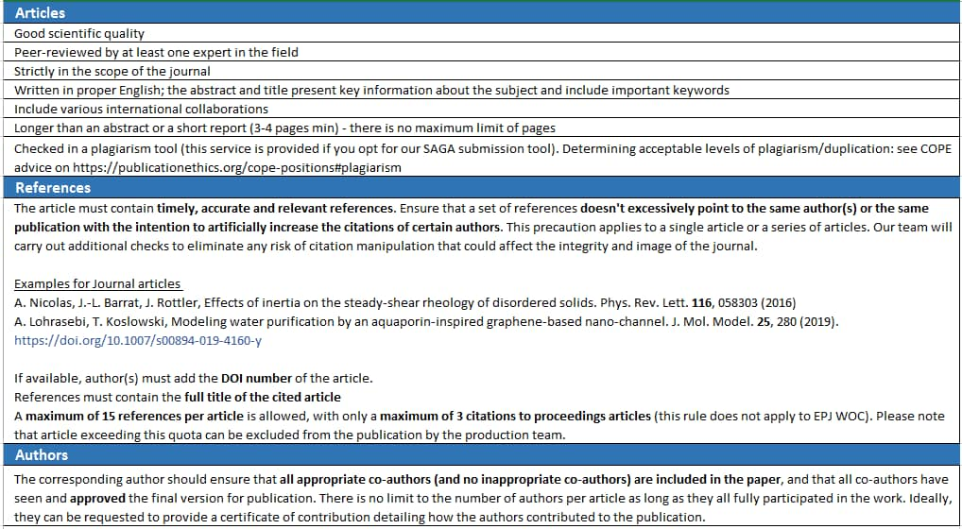

Citations

Authors must cite relevant, timely, and verified literature to support the claims made in their article. Authors should:
— Ensure that statements in their article which rely on external sources are cited accurately.
— Ensure that all citations in their article can be verified through a permanent Digital Object Identifier or other permanent identifier.

References
Online references will be hyperlinked to their original source, only if possible. To enable this linking extra care should be taken when preparing reference lists. If your reference citations are incorrect or incomplete (e.g., missing author name, or an incorrect volume number or page), the associated hyperlinks may fail, and the usefulness of your paper in the online environment may be diminished.
References should be cited in the text by placing sequential numbers in brackets (for example, [1], [2, 3], [4-7]). They should be numbered in the order in which they are cited. A complete reference should provide enough information to locate the article. References to printed journal articles should typically contain:
• The authors, in the form: initials of the first names followed by last name (only the first letter capitalized with full stops after the initials),
• The title of the article
• The journal title (abbreviated),
• The volume number (bold type),
• The article number or the page numbers,
• The year of publication (in brackets),
• The DOI number (digital object identifier)

Here are some examples:

Journal articles
- A. Nicolas, J.-L. Barrat, J. Rottler, Effects of inertia on the steady-shear rheology of disordered solids. Phys. Rev. Lett. 116, 058303 (2016)
- A. Lohrasebi, T. Koslowski, Modeling water purification by an aquaporin-inspired graphene-based nano-channel. J. Mol. Model. 25, 280 (2019). https://doi.org/10.1007/s00894-019-4160-y
- M. Ben Rabha, M.F. Boujmil, M. Saadoun, B. Bessaïs, Eur. Phys. J. Appl. Phys. (to be published)
Books
- J. Couturier, Y.H. Abou and E. Grolleau, Element of nuclear safety, (EDP Sciences, Les Ulis, 2019)
- M.N. Ozisik, Radiative transfer and interactions with conduction and convection (John Wiley and Sons, New York, 1973)
Proceedings
- J. Rhodes, K. Smith, D. Lee, CASMO-5 development and applications, in Proceedings of the PHYSOR-2006 conference, ANS Topical Meeting on Reactor Physics, Vancouver, BC, Canada, September 10-14, September 10-14 (2006), B144
Theses
- S. Azzaoui, SCALE-6 fuel depletion analyses: Application to the ARIANE program, Master Thesis, SCK-CEN, Belgium, 2010
- K. Ambrožič, L. Snoj, Characterization of gamma field in the JSI TRIGA reactor, Ph.D. thesis, University of Ljubljana, Faculty of Mathematics and Physics (2020)

